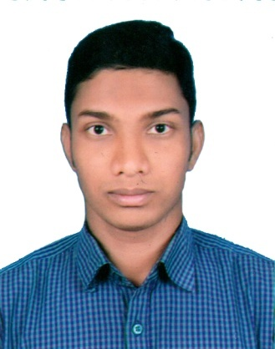

**RESUME OF**

**MD. MEHEDI HASAN**

BSS in Sociology from Rajshahi College, Rajshahi.

|  |  |
| --- | --- |
| Mobile  E-mail  Age  Blood group  Father’s Name  Mother’s Name  National Id No  Mailing Address  Permanent Address | **:** 01731-320877, 01516-144226  **:** mehedihasan22414@gmail.Com  **:** 24 Years (15-12-1994)  **:** B+  **:** Md. Afjal Hossain  **:** Mst. Karima Khatun  **:** 5504549485  **:** Rajshahi College Muslim Hall  **:** Vill: Satnoil, Post: Nayagola Hat, P.S.: Chapainawabganj Sadar, Dist: Chapainawabganj**.** |

**CAREER OBJECTIVE:**

I am very interested to working in the Marketing sector. Where there are opportunities to use my possibilities, creativity, adaptability and skills. I want to serve your organization face to face in the competitive world of marketing and establish a career for myself.

**EDUCATIONAL QUALIFICATION:**

|  |  |  |  |  |  |
| --- | --- | --- | --- | --- | --- |
| **Exam Title** | **Major** | **Institutes** | **Passing Year** | **Result** | **Duration** |
| BSS | Sociology | Rajshahi College, Rajshahi | 2018 | 3.10/4 | 4 Years |
| HSC | Humanities | Nawabganj Govt. College, Chapainawabganj | 2013 | 4.30/5 | 2 Years |
| SSC | Humanities | Nayagola High School, Chapainawabganj | 2011 | 4.38/5 | 2 Years |

**TRAINING:**

|  |  |  |  |  |  |
| --- | --- | --- | --- | --- | --- |
| **S. N** | **Title** | **Organization** | **Duration** | **Institute** | **Year** |
| 1. | **Computers** | Bangladesh Computer Council | 3 Months | Nawabganj Govt. College | 2012 |
| 2. | **Fire Extinguishing Rescue, First Aid and Earthquake** | Fire Service and Civil Defense, Rajshahi | 3 Days | Rajshahi College | 2017 |

**WORKSHOP:**

* “Career Development Workshop” Nitol Niloy Group, In Association with Rajshahi College Career Club.

**EXTRA CO-CURRICULAR ACTIVITIES:**

* Former Member of Rover Scouts from 2014 to 2019.
* Participated in social event such as Winter clothing distribution program, Tree plantation, Cleaning expedition etc.
* In my academic career I had arranged Study tour several times and also Participated and lead many cultural program.

**PERSONAL ATTRIBUTES:**

* Good Analytical Skills
* Motivational and leadership skills.
* Negotiation Convincing Skills
* Ability to work as individual as well as in group.
* Ability to produce best result in pressure situations.
* Easily adaptable to any new technology with minimum training.
* Highly energy work ethic and commitment to client services.

**ROVER SCOUT CAMP:**

* 11th National Rover Moot-2017, Gopalganj.
* 1st Regional Comdeca-2017, Gazipur.
* 18th Regional Rover Moot-2017, Gazipur.
* 6th National Comdeca-2018, Chandpur.
* Century Rover Moot-2018, Gazipur.

**TECHNICAL SKILLS:**

* + - * Working Skills in M.S Word, Excel, Power Point.
      * Internet Browsing, E-mailing and Avro Typing.

**REFERENCE:**

|  |  |
| --- | --- |
| Dr. Naznin Sultana  Professor  Dept. of Sociology  Rajshahi College, Rajshahi  Contract : 01715804256  Teacher | Mst. Rozina Afroj  Assistant Professor  Dept. of Sociology  Rajshahi College, Rajshahi  Contact**:** 01717088990  Teacher |

**DECLARATION:**

I hereby declare that the Information furnished above is true to the best of my knowledge.

|  |
| --- |
| Signature |
| **Md. Mehedi Hasan** Date**: 25-11- 2019** |